MED D – Disenrollment Transfer Procedures

General Information
Disenrollment Reasons Transferred to Premium Billing Specialized Team
Disenrollment Reasons Transferred to Specialized Member Services Team (SMST)
Disenrollment Reasons Handled by the CCR
Related Documents

Description: The document assists the MED D Customer Service Representative with identifying the reason for disenrollment and where to transfer the call.

Target Audience: SilverScript

General Information
When researching the reason why a MED D Beneficiary has been disenrolled, the CCR should refer to the PeopleSafe - Medicare D Inquiry tab and the Disenrollment Reason.

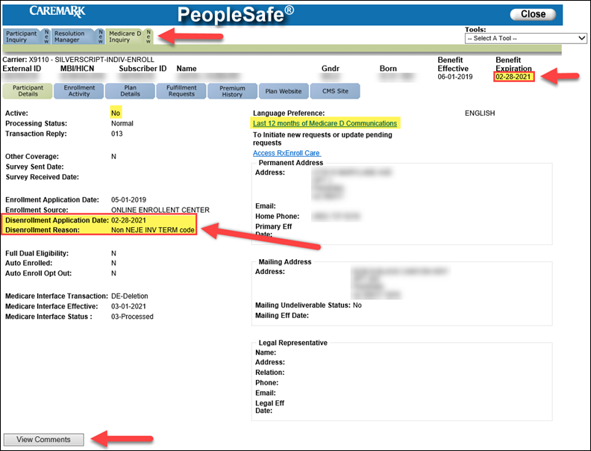

Note:
- The CCR should also reference ALL disenrollment letters in the Last 12 months of Medicare D Communications, ALL previous call notes in the Participant Inquiry tab - View Comments, and Medicare D Inquiry tab - View Comments for processing notes.

Top of the Document

Disenrollment Reasons Transferred to Premium Billing Specialized Team
The below Disenrollment Reasons MUST WARM Transferred to the Med D Premium Billing Specialized Team at 1-866-824-4055.

- INVOLUNT DISENROLL NO PAY PREM
- NON NEJE INV TERM

Refer to Aetna MED D - SilverScript Only - Premium Billing Warm Transfer Job Aid.

Top of the Document

Disenrollment Reasons Transferred to Specialized Member Services Team (SMST)
The below Disenrollment Reasons MUST WARM Transferred to the Specialized Member Services Team (SMST). For HealthPlan/EGWP transfer to 1-844-234-8264; for SilverScript transfer to 1-833-458-0858.

- DISENROLL - NEW MMP
- DISENROL - NEW MCO
- INCARCERATED
- UNLAWFULLY PRESENT
- LOSS PART D ELIGIBILITY
- MEMB DECEASED
  - Beneficiary is not deceased (Incorrect Date of Death Reported)
- NOT ENROLLED
- OUT OF AREA DISENROLLMENT

Refer to MED D - Guide to Transferring a Call.

Top of the Document

Disenrollment Reasons Handled by the CCR

Disenrollment Reason | Process
UNLAWFULLY PRESENT | MED D – SilverScript and Blue MedicareRx (NEJE) – Resolving Eligibility Issues for Incarcerated or Not Lawfully Present Beneficiaries
INCARCERATION | MED D – SilverScript and Blue MedicareRx (NEJE) – Resolving Eligibility Issues for Incarcerated or Not Lawfully Present Beneficiaries
INVOL EGWP DSNRLL - ADV NTC | Review the applicable CIF for additional information for appropriate team that would handle the disenrollment.
IRMAA DISENROLLMENT | MED D SilverScript - Process for Good Cause Determinations for Nonpay of IRMAA  MED D Blue MedicareRx (NEJE) - Process for Good Cause Determination for Non-payment of Part D-IRMAA
MEMB DECEASED | MED D - Deceased Beneficiary  Note: Do NOT send a RM task to notify Enrollment Operations of the beneficiary’s death.

Top of the Document

Related Documents
- Grievance Standard Verbiage (for use in Discussion with Beneficiary) section in MED D - Grievances Index
- Aetna MED D - SilverScript Only - Premium Billing Warm Transfer Job Aid
- MED D - Guide to Transferring a Call

Parent SOP: CALL-0048: Medicare Part D - Customer Care Call Center Requirements, CVS Caremark Part D Services, L.L.C.
Abbreviations/Definitions: Abbreviations / Definitions

Top of the Document

Not To Be Reproduced Or Disclosed to Others Without Prior Written Approval
ELECTRONIC DATA = OFFICIAL VERSION – PAPER COPY = INFORMATIONAL ONLY

